**Backend of login and registration page:**

**Backend of registration page:**

Create table in MYSQL:



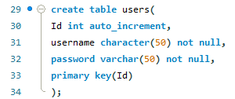

nodejs-API file on registration page:

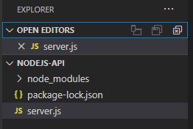

In server.js file:

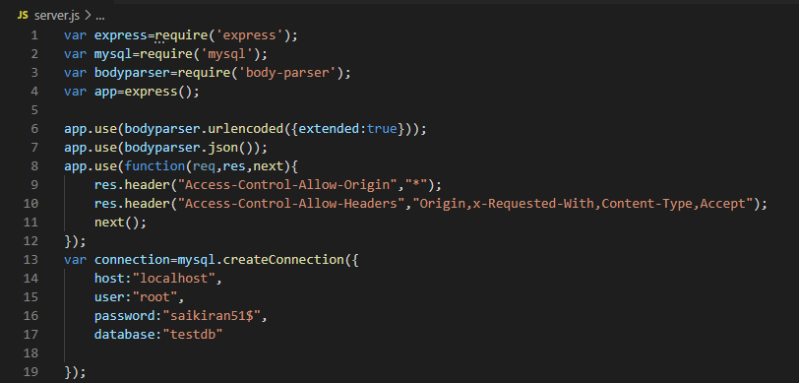

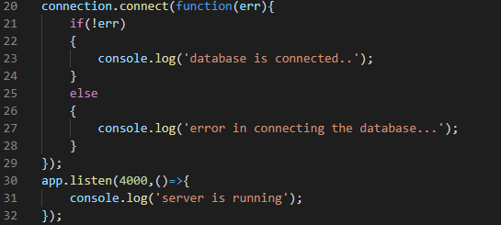

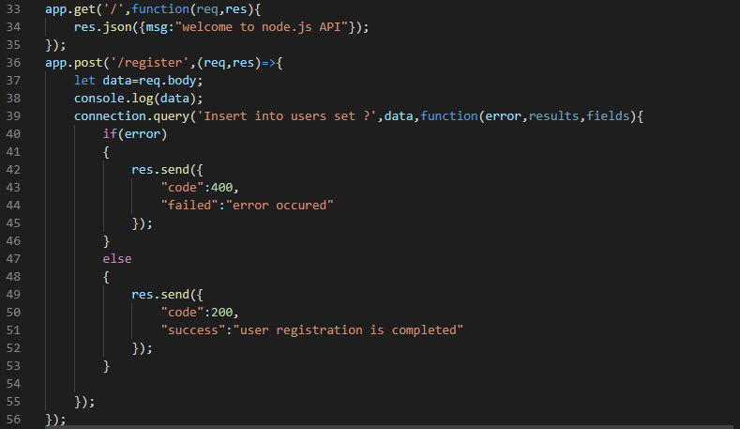

Now check whether code is running properly or not:

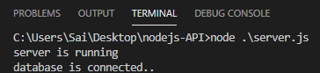

Now checking with postman:

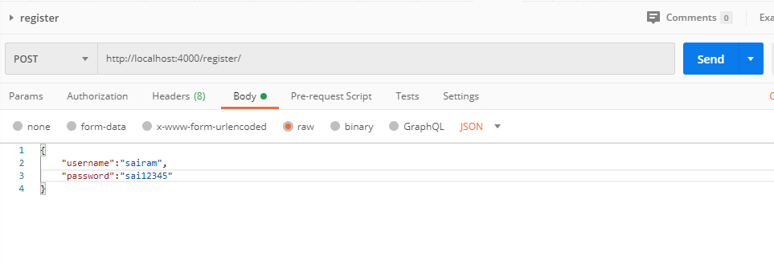

Now check in visual studio code and mysql weather data is inserted or not

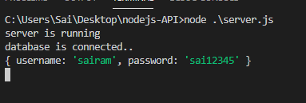

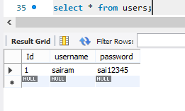

Data is inserted successfully:

Now inserting data from register.html page:

Give api connection to register.html page:

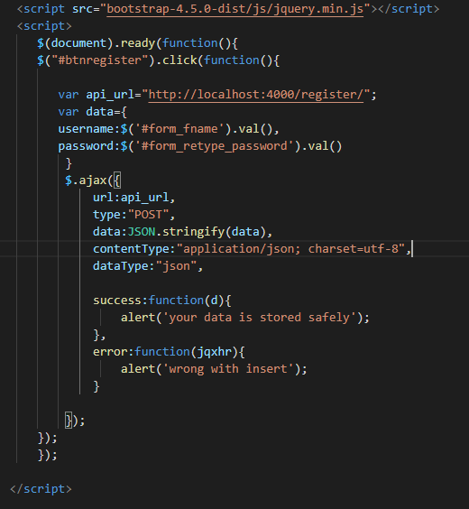

Now, inserting the data from login.html page:

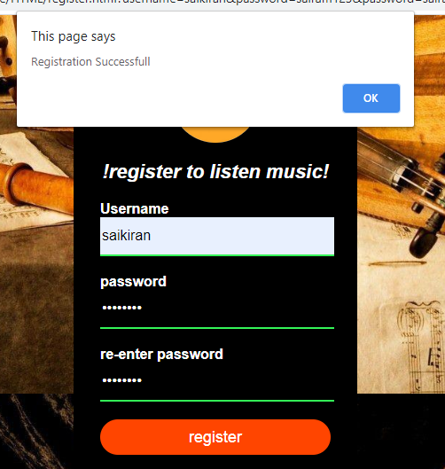

Now checking the database part:

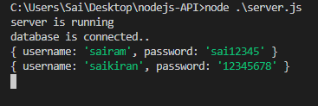

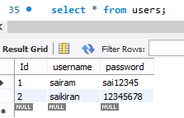

Data is successfully inserted into the database

**Back-end of login.html page**

In server.js file:

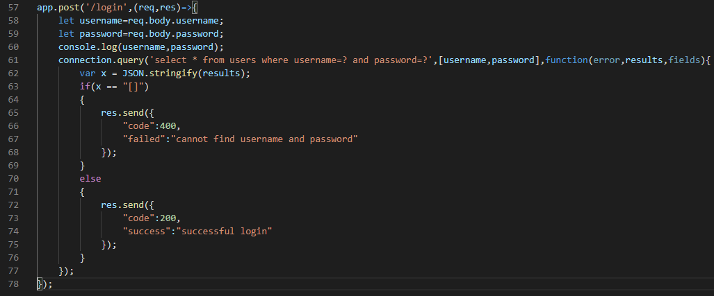

Now checking in postman whether data is validated or not:

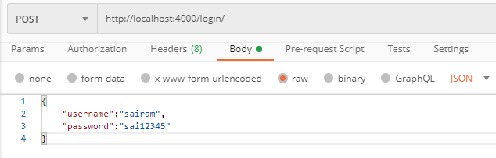

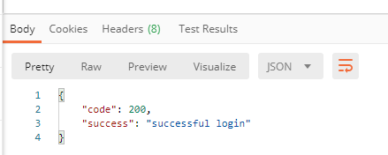

Now inserting some invalid data

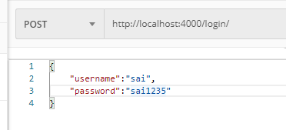

We can see the the entered data is invalid

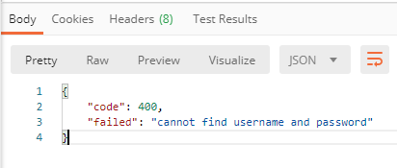

Now checking the database part:

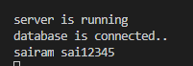

Now connecting API with login.html page:

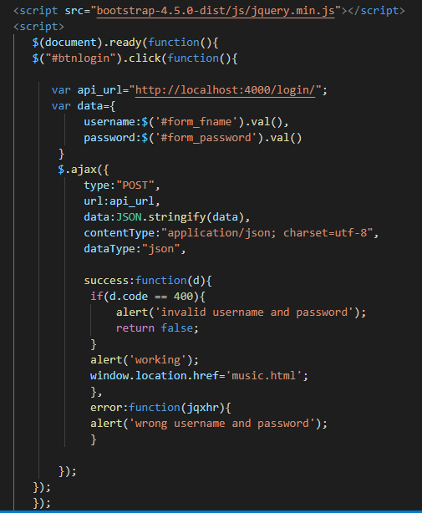

Now entering the dat in login.html page:

Now we have run**” LIVE SERVER PREVIEW”** in visual studio code.

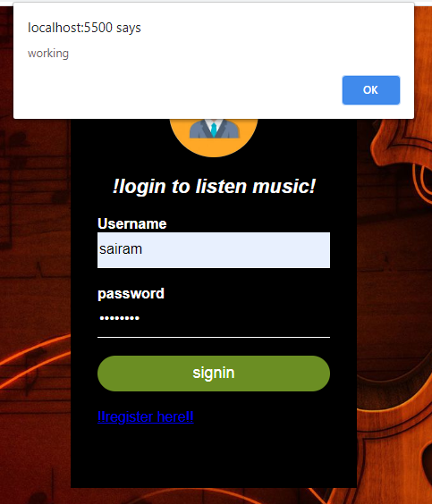

And it will redirect to the **music.html** page



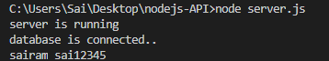

Now giving invalid details which is not present in the MYSQL database

Table shows the data which is already present.

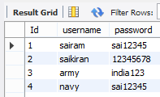

Now entering invalid details which are not present in the database:

